**Chapter 1**

**Integration**

**1.7. Integrals Resulting in Inverse Trigonometric Functions**

**Section Exercises**

**In the following exercises, evaluate each integral in terms of an inverse trigonometric function**.

391. 

Answer: 

393. 

Answer: 

395. 

Answer: 

**In the following exercises, find each indefinite integral, using appropriate substitutions.**

397. 

Answer: 

399. 

Answer: 

401. 

Answer: 

403. Explain the relationship  Is it true, in general, that 

Answer:  So,  They differ by a constant.

405. Explain what is wrong with the following integral: 

Answer:  is not defined as a real number when 

**In the following exercises, solve for the antiderivative  of *f* with  then use a calculator to graph *f* and the antiderivative over the given interval  Identify a value of *C* such that adding *C* to the antiderivative recovers the definite integral **

407. **[T]**  over 

Answer:

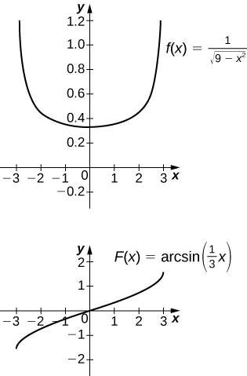

The antiderivative is  Taking  recovers the definite integral.

409. **[T]**  over 

Answer:

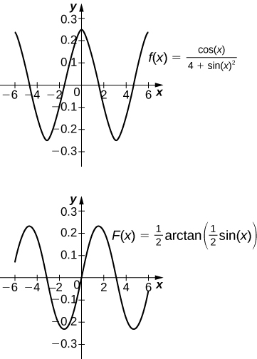

The antiderivative is Taking recovers the definite integral.

**In the following exercises, compute the antiderivative using appropriate substitutions.**

411. 

Answer: 

413. 

Answer: 

415. 

Answer: 

**In the following exercises, use a calculator to graph the antiderivative  with  over the given interval  Approximate a value of *C*, if possible, such that adding *C* to the antiderivative gives the same value as the definite integral **

417. **[T]**  over 

Answer:

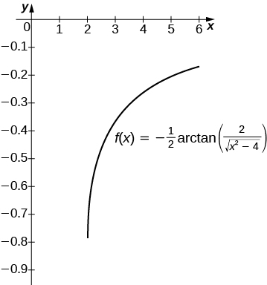

The antiderivative is  Taking  recovers the definite integral over.

419. **[T]**  over 

Answer:

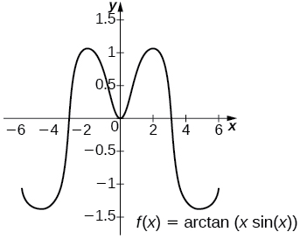

The general antiderivative is  Taking  recovers the definite integral.

421. **[T]**  over 

Answer:

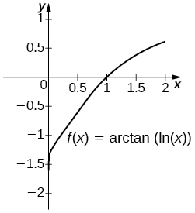

The general antiderivative is  Taking  recovers the definite integral.

423. 

Answer: 

425. 

Answer: 

427. 

Answer: 

**In the following exercises, compute each definite integral.**

429. 

Answer: 

431. 

Answer: 

433. For  compute  and evaluate  the area under the graph of  on 

Answer:  as 

435. Use the substitution  and the identity  to evaluate  (*Hint:* Multiply the top and bottom of the integrand by )

Answer: Using the hint, one has  Set  Then,  and the integral is  If one uses the identity  then this can also be written 

437. **[T]** Approximate the points at which the graphs of  and  intersect, and approximate the area between their graphs accurate to three decimal places.

Answer:  The left endpoint estimate with  is 2.796 and these decimals persist for .

**Chapter Review Exercises**

***True or False.* Justify your answer with a proof or a counterexample. Assume all functions  and  are continuous over their domains.**

439. If   for all  then the right-hand rule underestimates the integral  Use a graph to justify your answer.

Answer: False

441. If  for all  then 

Answer: True

**Evaluate the Riemann sums  for the following functions over the specified interval. Compare your answer with the exact answer, when possible, or use a calculator to determine the answer.**

443.  over 

Answer:  exact answer: 4

445.  over 

Answer:  exact answer: 5.870

**Evaluate the following integrals**.

447. 

Answer: 

449. 

Answer: 1

**Find the antiderivative.**

451. 

Answer: 

453. 

Answer: 

**Find the derivative.**

455. 

Answer: 

457. 

Answer: 

**The following problems consider the historic average cost per gigabyte of RAM on a computer.**

|  |  |
| --- | --- |
| **Year** | **5-Year Change ($)** |
| 1980 | 0 |
| 1985 | –5,468,750 |
| 1990 | **–**755,495 |
| 1995 | –73,005 |
| 2000 | –29,768 |
| 2005 | –918 |
| 2010 | –177 |

459. If the average cost per gigabyte of RAM in 2010 is $12, find the average cost per gigabyte of RAM in 1980.

Answer: $6,328,113

461. Find the average cost of 1GB RAM for 2005 to 2010.

Answer: $73.36

463. What is the average velocity of the bullet for the first half-second?

Answer: 

This file is copyright 2016, Rice University. All Rights Reserved.